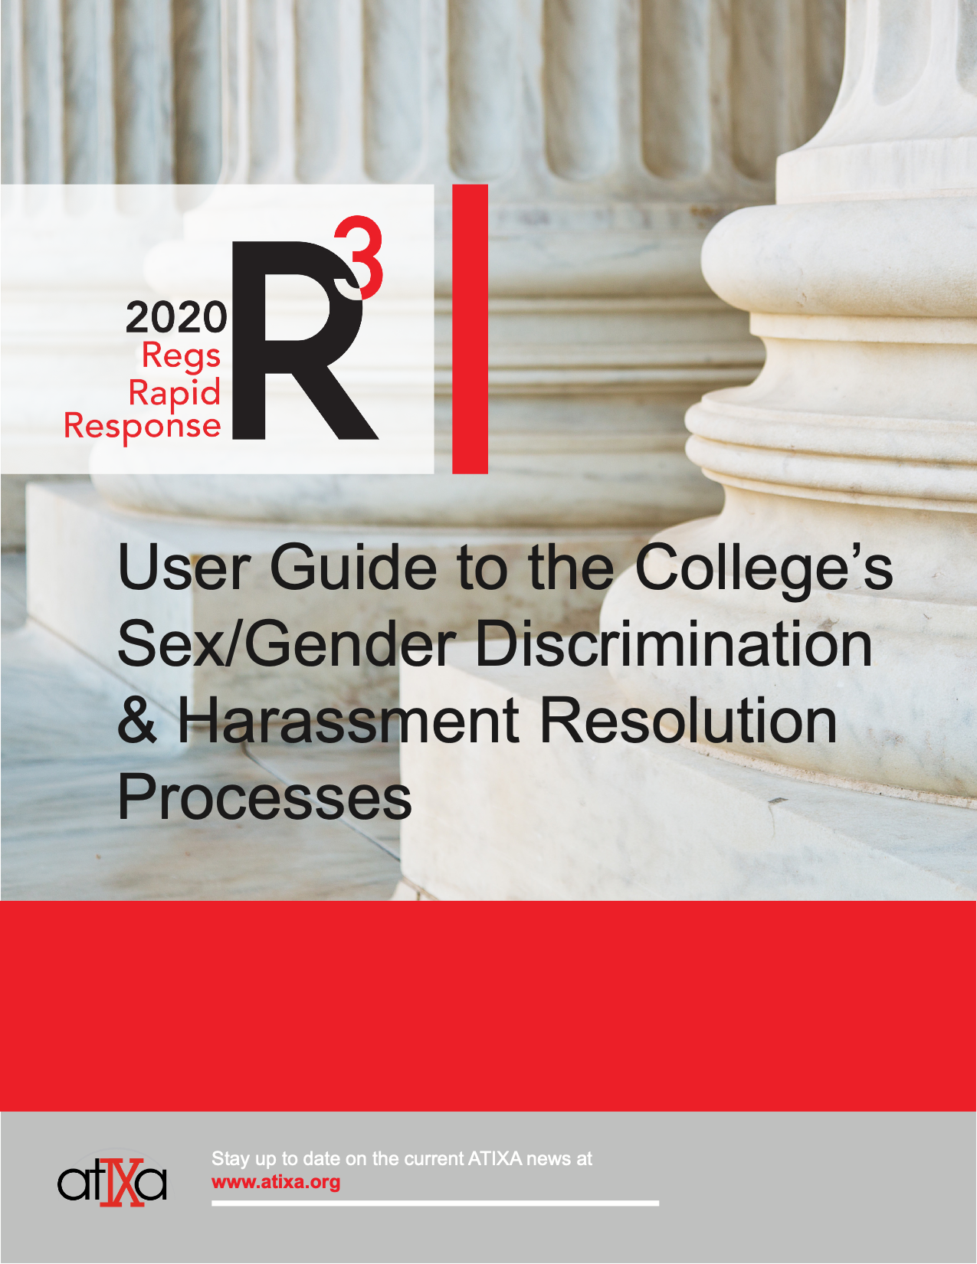
User Guide to the College’s Sex/Gender Discrimination & Harassment Resolution Processes

Introduction

If you’ve tried to read the college’s new procedures for addressing sexual offenses (live link), we can’t blame you if it’s been a challenge to understand some of their complexity. This brief guide is intended to help explain the changes and make the new resolution process more transparent to you.

A Brief History

In 2011, the Obama-era Department of Education (ED) perceived that colleges needed to be more victim-centered in addressing sexual violence and should have more transparent and accessible policies and procedures for addressing complaints. At the instigation of then Vice-President Joe Biden, ED issued a set of guidelines for colleges under Title IX in what is known as the Dear Colleague Letter. That letter resulted in investigation-centered approaches that were trauma-informed, confidential, and relatively informal. Almost immediately, accused students and employees began to sue colleges for violations of their due process rights. By 2017, ED under the Trump administration had taken a different perspective and withdrew the 2011 Dear Colleague Letter while also announcing that new Title IX regulations were needed to better safeguard the due process rights of accused individuals. The regulatory process took two years, with new regulations published in May 2020 that took effect on August 14, 2020.

New Policies and Procedures

The 2020 Title IX regulations required all colleges to revise or rewrite their policies and procedures for addressing sex offenses, including sexual harassment, sexual assault, domestic violence, dating violence, and stalking. The college has worked diligently to ensure that its newly revised policies and procedures (live link) are now compliant with these regulations. This was not an easy process. The regulations include fifteen pages of new requirements, and more than 2,000 pages of explanation of the provisions within those fifteen pages. They are complex and legalistic. Just trying to explain parts of this new process to you here requires a document that is seven pages long. The bottom line is that the college’s policies are not all that different than before – the same types of offenses are still against college policy – but the procedures for resolution of complaints are substantially changed.

To summarize:
- Title IX protects students and employees who are impacted by sexual harassment, sexual assault, domestic violence, dating violence, and stalking. When these behaviors occur, and a formal complaint is made, the college is obligated to address and remedy them and ensure that no one is denied effective access to the educational program of the college.
- Colleges have jurisdiction requirements that they must follow to determine whether a complaint falls within Title IX or is to be addressed within other college policies and procedures.
- Complainants are well-protected by the regulations in terms of supportive measures that are offered by colleges to try to address the impact of sex offenses.
- Complainants and respondents are each entitled to an advisor of their choosing (who can be an attorney) throughout the resolution process, and the college can provide this advisor to each party, if needed.
- The regulations have now created options for informal resolution that were discouraged by the Dear Colleague Letter.
- To protect the due process rights of respondents, colleges are required to use a formal grievance process for certain types of allegations. That formal process includes an investigation, a live hearing, questioning of the parties through their advisors, a determination by an objective decision-maker, and an appeal.

As a result of these changes, the college has worked hard to balance the rights of all parties, and to create a process that is fair, transparent, and compliant. However, it isn’t an ideal process and isn’t particularly user-friendly, and we acknowledge this. This may not be the policy or process the college would have created if we had the flexibility to define misconduct and the process to respond, but the government has intervened, and the college must comply. To offset the more complex aspects of the process, the college is training a pool of advisors to help parties through every step of the process. They can guide and advise all parties on how to best protect your rights to educational access. We’ve also created guides like this, and the flowchart below, to help make the process more accessible and understandable.

One last key point to understand is that Title IX isn’t the only governing law here. The college must also comply with [state laws that address sex offenses, as well as] a federal law called the Violence Against Women Act (VAWA), Section 304, which also protects college community members when they experience sex offenses.

Navigating the new Rules Together

When the college receives a complaint, there are four possibilities that you should be aware of because they govern how the college will proceed:

- The complaint falls within Title IX AND is covered by the 2020 Title IX regulations
- The complaint falls within Title IX but is not covered by the 2020 Title IX regulations
- The complaint falls within VAWA Section 304
- The complaint does not fall within Title IX or VAWA Section 304

Depending on which of these four possibilities the complaint falls within, the college must apply different policies and/or procedures, accordingly. As shorthand, we call the procedures that comply with the 2020 Title IX regulations (36 CFR Part 106.45) “Process A” and the alternate process to resolve complaints outside of Process A we term “Process B.” Like Process A, Process B is a civil rights-based process that is compliant with Title IX and VAWA Section 304 but is less formal because it is outside the jurisdiction requirements of the regulations.

Processes A and B cannot both be simultaneously applied by the college. The regulations mandate that if both can apply, Process A must be applied, not B. Thus, if A applies, B cannot. Further the regulations specify that Process B cannot be used a make an end-run to avoid Process A if Process A applies, regardless of what process each party might prefer. For a college to choose Process B when Process A applies would be considered a form of retaliation against the respondent.

Let’s take each in turn to better explain this.

- The complaint falls within Title IX AND is covered by the 2020 Title IX regulations

The complaint will fall in this category when it alleges sexual harassment, sexual assault, domestic violence, dating violence, and/or stalking (as defined by college policy, if proven) AND the conduct:
- Happened in the United States;
- Occurred where the college controls the context of the incident (a college program or property, typically);
- The school has jurisdiction over the respondent as a student or employee; and
- Happened to a complainant who at the time of the complaint was participating in or attempting to participate in the college’s educational program.

These jurisdictional requirements are spelled out by the 2020 Title IX regulations and are rigid. If any of these requirements fails to be met, the college is required to “technically” dismiss the complaint. More in a bit on what happens if there is a technical dismissal, because that is not the end of the process. If these requirements are met, the resolution process will be the Formal Grievance Process described in Process A (insert link here).

- The complaint falls within Title IX but is not covered by the 2020 Title IX regulations

The complaint will fall in this category if it does not involve sexual harassment, sexual assault, domestic violence, dating violence, and/or stalking, but the allegations pertain to sex discrimination more broadly, such as:
- disparate treatment, e.g., discrimination against a pregnant student; denial of access to a program; inequitable funding on the basis of sex);
- forms of sexual orientation discrimination;
- forms of gender identity/expression discrimination [based on sex stereotypes].

When a complaint is filed under Title IX, the regulations require these types of allegations to be technically dismissed. The college will then address them under Process B. If there is no formal complaint made, they can be addressed using Process B without needing to go through a dismissal first with respect to Process A.

- The complaint falls within VAWA Section 304 (this could be an overlay with 1 or 2, above, or a stand-alone status)

The complaint will fall in this category if it is not within the Title IX jurisdiction above (see four bullet points), but still involves sexual violence, dating violence, domestic violence, or stalking. In this case, the college must address the conduct under procedures that comply with VAWA Section 304, and the complaint can be then addressed under Process B. If there is no formal complaint made, the allegations can be addressed using Process B without needing to go through a dismissal first with respect to Process A.

- The complaint does not fall within Title IX or VAWA Section 304

Finally, where the complaint falls within neither Title IX nor VAWA Section 304, the college is not required by law to act on the complaint. However, the college will act with discretionary jurisdiction, meaning that it still thinks it is important to address the allegations even if law does not require it. The complaint can be then addressed under Process B. If there is no formal complaint made, the allegation can be addressed using Process B without needing to go through a technical dismissal first with respect to Process A.

Hopefully, what you now understand from this section is that the incidents that fall within Process A occur within a narrow range. They must fit the description of sexual harassment, sexual assault, domestic violence, dating violence, or stalking (as defined by college policy, if proven) in the United States, where the college controls the context of the incident and has control over the respondent and the complainant is participating in or attempting to participate in the college’s educational program. Outside of that, all sex offenses or sex discrimination complaints will fall within Process B, including those, for example, that happen between two students, off-campus, on private property.

The last part of jurisdiction to understand is dismissal. As noted above, the college is mandated to and must dismiss a formal complaint or any allegations therein if, at any time during the Process A investigation or hearing, it is determined that:

- The conduct alleged in the formal complaint would not constitute sexual harassment, sexual assault, dating violence, domestic violence or stalking as defined in policy, even if proved; and/or
- The conduct did not occur in an educational program or activity controlled by the school (including buildings or property controlled by recognized student organizations), and/or the school does not have control of the respondent; and/or
- The conduct did not occur against a person in the United States; and/or
- At the time of filing a formal complaint, a complainant was not participating in or attempting to participate in the education program or activity of the recipient.
Then there are three permissive dismissal provisions. The college may dismiss a formal complaint or any allegations therein if, at any time during the investigation or hearing:
- A complainant notifies the Title IX Coordinator in writing that the complainant would like to withdraw the formal complaint or any allegations therein; or
- The respondent is no longer enrolled in or employed by the recipient; or
- Specific circumstances prevent the recipient from gathering evidence sufficient to reach a determination as to the formal complaint or allegations therein.
Upon any dismissal, the college will send written notice of the dismissal and the rationale for doing so simultaneously to the parties. This dismissal decision is appealable by any party under the college’s procedures for appeal. The effect of a dismissal (permissive or mandated) is either that the complaint is done, or that the school reinstates it, usually within Process B. Even if a complaint is done, supportive measures are still made available to the parties. Understanding these mechanisms can be helpful, but we know they’re complex, so don’t hesitate to call on the Title IX Coordinator for further explanation.

College-provided advisors may be called on to help determine if a someone wants a complaint to be reinstated, or even under what process it should be filed in the first place. Where dismissed, advisors will be able to advise the parties on whether they want to appeal (for example, a complainant may be pleased by a Process A dismissal if they would prefer Process B, whereas the respondent may feel the opposite) and what the effect of dismissal/reinstatement may be.

Live Hearings

We’ll conclude with a short section about live hearings under Process A. The live hearing component has received a lot of attention, so we wanted to take a moment to clarify some important details and hope they will help anyone making a decision about whether to file a formal Title IX complaint. The college has designed the process to be as humane and non-adversarial as possible, while assuring fairness to all participants.

- There are informal resolution options offered by the college. The college cannot and will not force or coerce any student or employee into an informal resolution. Although it is true that a formal complaint must first be filed, that does not mean a live hearing must occur. A formal complaint can also lead to an informal resolution process (link here) and should an informal resolution fail, a formal grievance process is always still available.
- Live hearings do not have to happen with all parties in the same room. Any or all parties can opt for virtual participation at any time. Even with a virtual hearing, all participants will be able to see and hear each other throughout the hearing.
- Although there is “cross-examination” during the hearing, it may not work the way you think. The parties cannot question each other directly, at all. The advisors to the parties ask the questions, and before they do, the Chair of the hearing rules on each question first. So, there is really only indirect questioning, not “cross-examination” like you might find in a courtroom.
- Even though advisors get to ask questions of parties and witnesses, you may find that most of the questions are posed by the neutral decision-makers. Once those questions are posed, they cannot be asked again by the advisors, so in most cases, the questions come to the parties from the decision-makers, not from the other party’s advisor.
- A written decision is issued, based on the preponderance of the evidence standard (whether a policy violation is more likely than not), and offers a clear rationale for the decision.
- The decision is appealable by all parties.
- The hearing process is kept confidential by the college.

The college has designed the process to be as humane and non-adversarial as possible, while meeting our obligations under this new law and assuring fairness to all participants. For questions or confidential discussion about any options and college processes, please contact [insert here]:

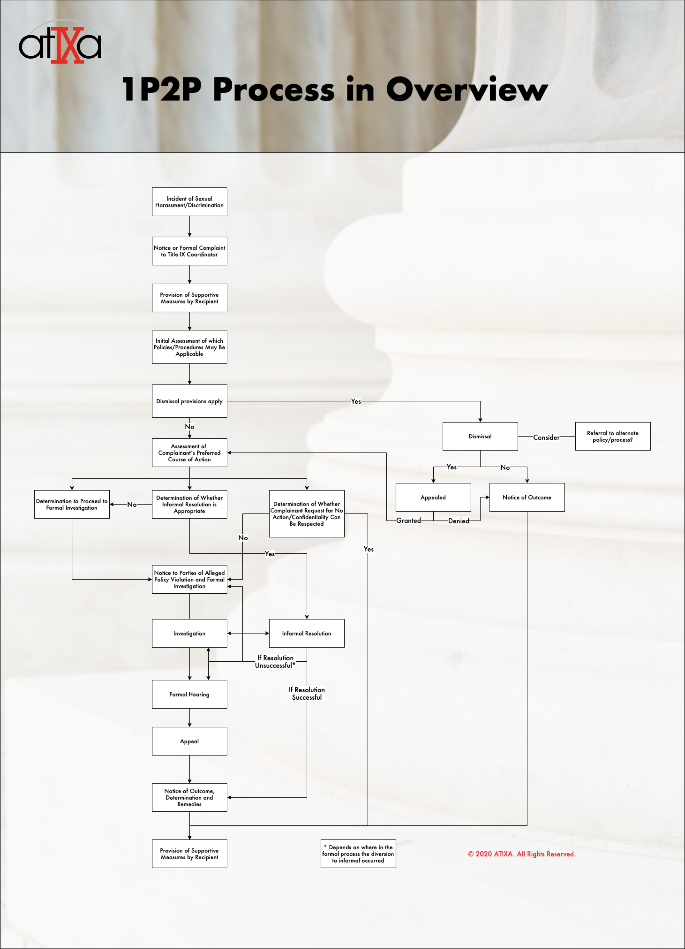

This could be an overlay with 1 or 2, above, or a stand-alone status.
Unless this complaint is one initiated by the Title IX Coordinator themselves because of some serious risk to the campus community.

